# Phase III: Dashboard Implementation

By [Asha Mishra](mailto:amish140@asu.edu), [Taljinder Singh](mailto:tsingh80@asu.edu),[Jacob Kuriakose](mailto:jkuriak3@asu.edu), [Hitha Mahesh Gowda](mailto:hgowda4@asu.edu)

**Contents**

Section 1: The Dashboard

* + A figure of the dashboard
  + A brief explanation for what it is used for

Section 2: The Dataset

* + An explanation of the dataset, its attributes, and the pre-processing that was done on the data, if any

Section 3: Dashboard Users

* + An explanation for the dashboard users

Section 4: Questions

* + The list of questions that the dashboard will answer.

Section 5: Plots

* + For each plot, include a figure of its final shape in the dashboard, the question(s) it addresses and how it addresses it.

Section 6: Interactivity

* + An explanation of the controls that are included in the dashboard, if any, their functionality and the plots that they control.

## Section 1: The Dashboard

#### A figure of the dashboard

[Check the whole dashboard here!](https://public.tableau.com/app/profile/asha.mishra/viz/HRAnalyticsImplementationsbyGroup15/Dashboard2?publish=yes)

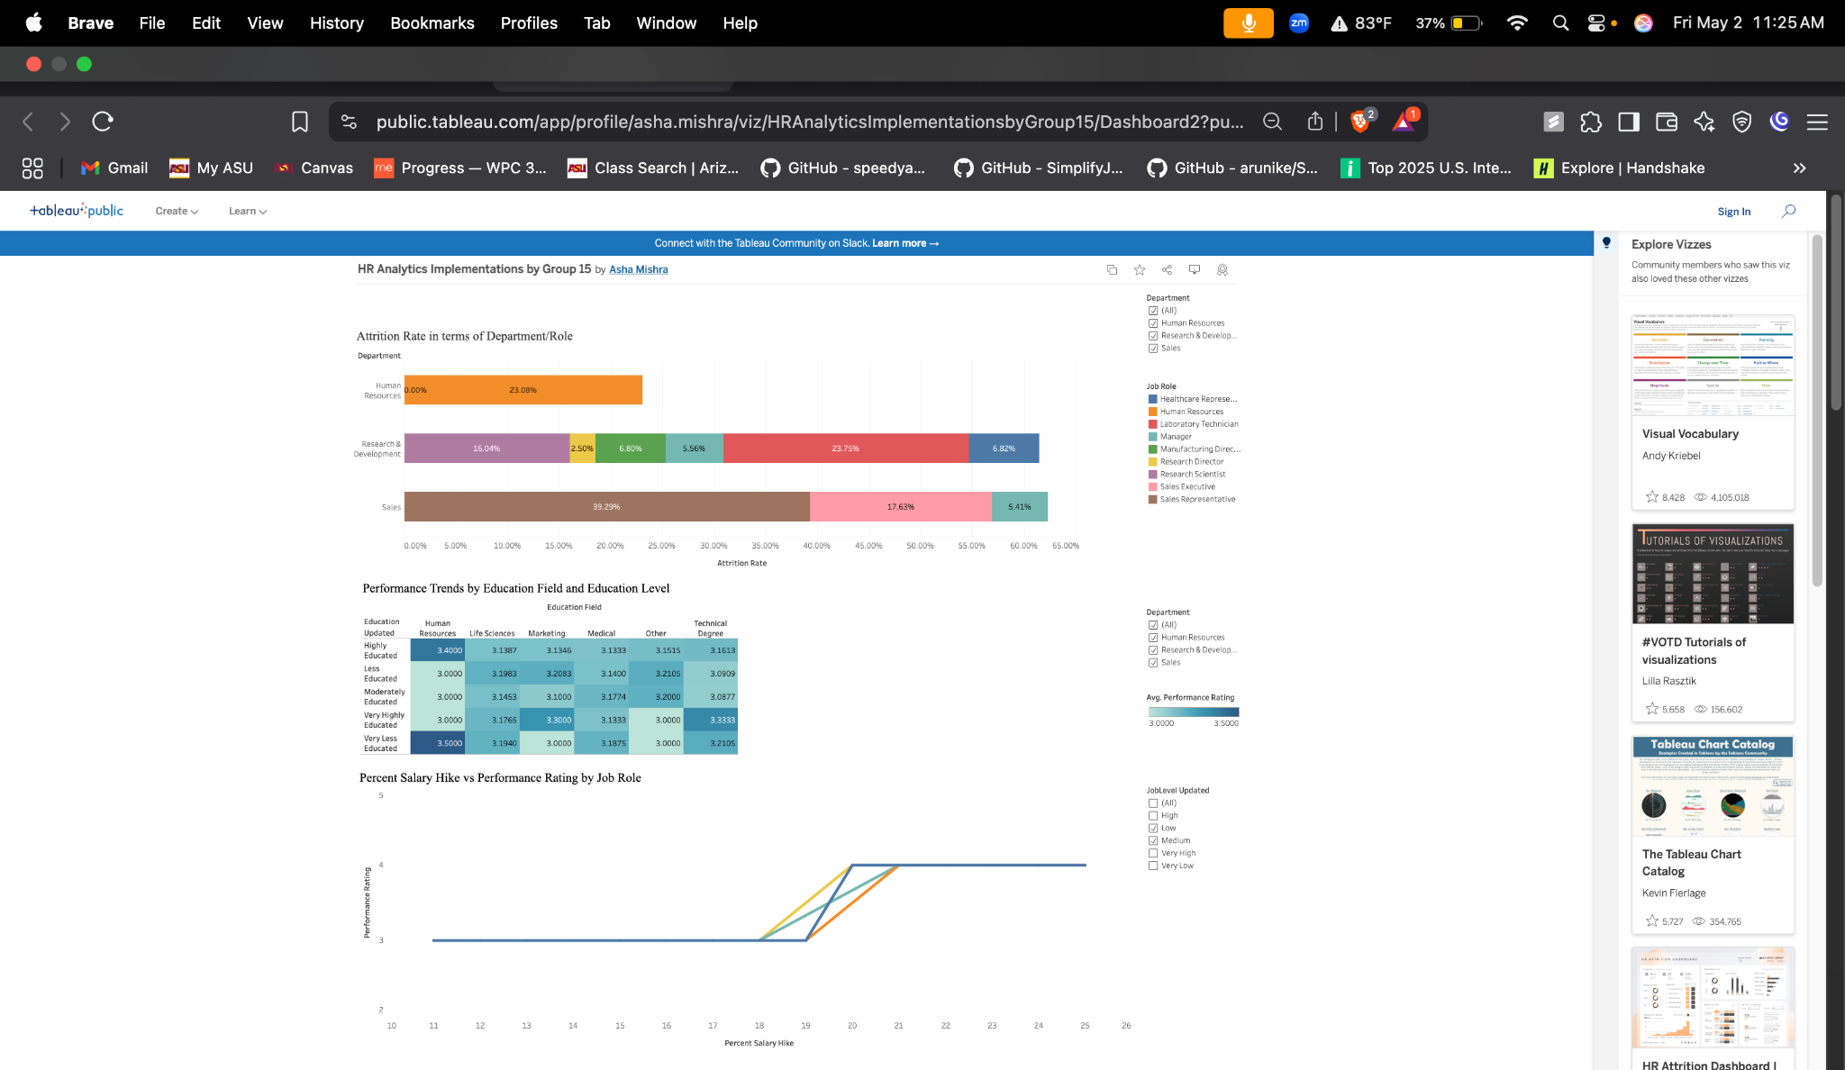

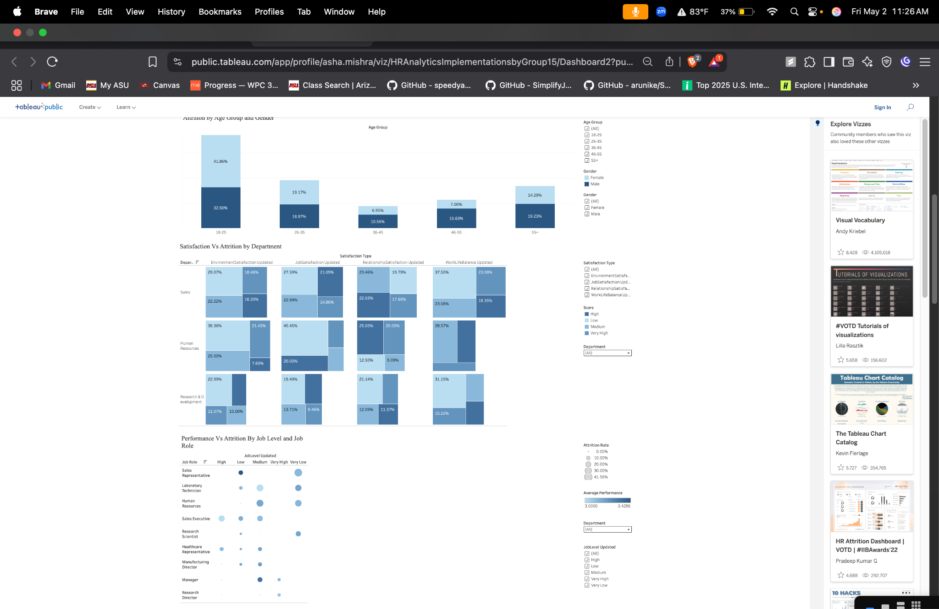

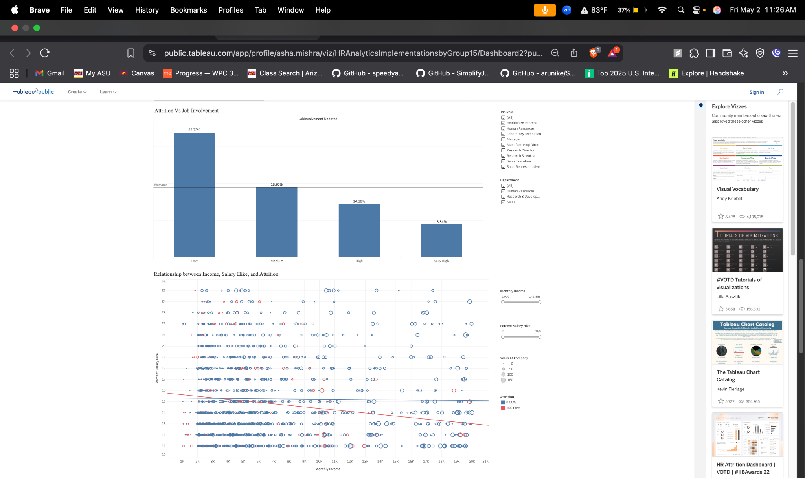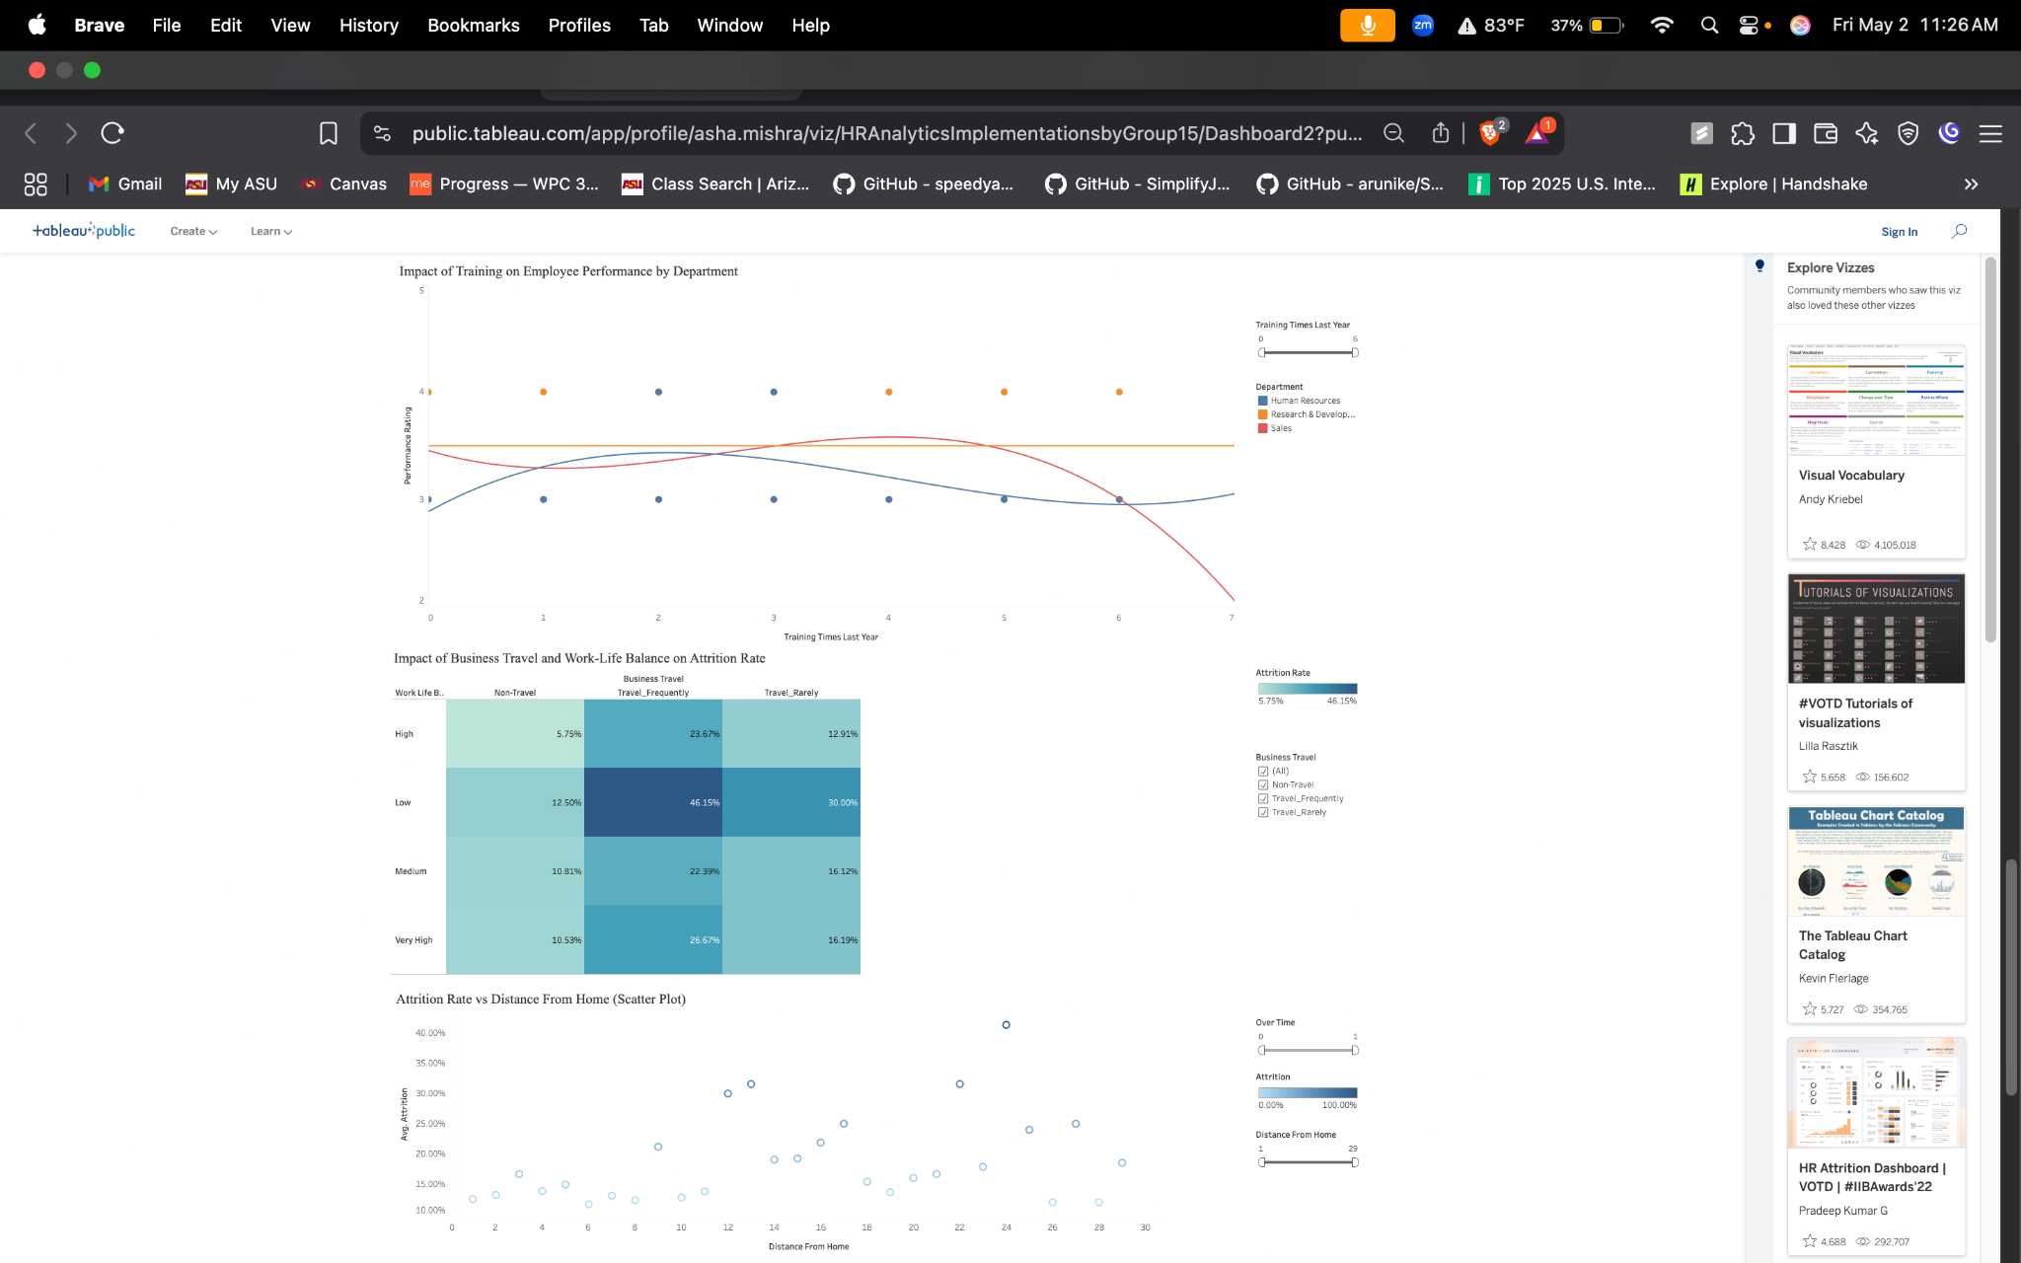

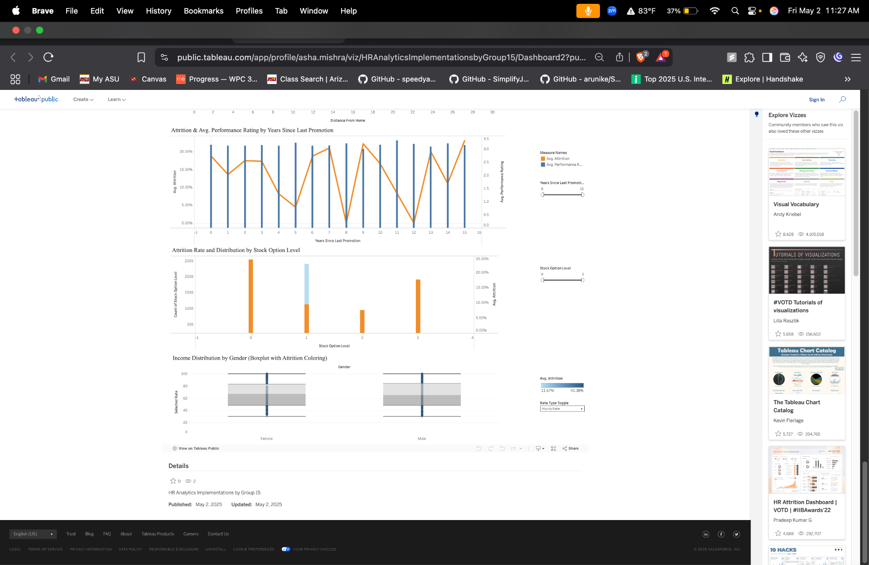

#### 

#### A brief explanation for what it is used for

The dashboard is designed to help HR professionals and business leaders analyze and visualize key workforce metrics, such as employee attrition, satisfaction, performance, compensation, and demographic trends. By presenting this information in an interactive and accessible format, the dashboard supports data-driven decision-making to identify retention risks, monitor employee engagement, and optimize HR strategies for improved organizational outcomes.

## Section 2: The Dataset

#### An explanation of the dataset, its attributes, and the pre-processing that was done on the data, if any

The provided dataset, "HR_Analytics.csv," contains detailed employee information typically used for HR analytics and workforce management. Each row represents an individual employee and includes the following key variables:

* EmpID and EmployeeNumber: Unique identifiers for each employee.
* Demographic Data: Age, AgeGroup, Gender, MaritalStatus, Education, EducationField.
* Employment Data: Department, JobRole, JobLevel, BusinessTravel, DistanceFromHome, EmployeeCount, StandardHours, Over18.
* Compensation Data: DailyRate, HourlyRate, MonthlyIncome, SalarySlab, MonthlyRate, StockOptionLevel, PercentSalaryHike.
* Performance and Satisfaction: PerformanceRating, EnvironmentSatisfaction, JobInvolvement, JobSatisfaction, RelationshipSatisfaction, WorkLifeBalance.
* Career Progression: TotalWorkingYears, YearsAtCompany, YearsInCurrentRole, YearsSinceLastPromotion, YearsWithCurrManager, NumCompaniesWorked, TrainingTimesLastYear.
* Attrition and Overtime: Attrition (Yes/No), OverTime (Yes/No).

This comprehensive dataset allows for in-depth analysis of employee demographics, compensation, satisfaction, performance, and attrition trends across various departments and roles.

**Pre-processing:**

All prep was performed in Tableau Prep Builder on the original HR Analytics CSV, producing Output.csv. Below are the details of the pre-processing steps performed:

**Dropped non-informative or constant fields:** EmpID, EmployeeNumber, EmployeeCount, MonthlyRate, Over18, SalarySlab, StandardHours

**Attrition:** Mapped Yes/No → 1/0

**BusinessTravel:** Clean labels; changed Travelrarely to Travel_rarely

**Education:** Convert to categorical (1 = Very Less Educated → 5 = Very High Educated).

**EnvironmentSatisfaction:** Convert to categorical (1 = Low, 2=Medium, 3=High, 4 = Very High).

**JobInvolvement:** Convert to categorical (1 = Low, 2=Medium, 3=High, 4 = Very High).

**JobLevel:** Convert to categorical (1 - Very Low, 5- Very High).

**JobSatisfaction:** Convert to categorical (1 = Low, 2=Medium, 3=High, 4 = Very High).

**OverTime:** Mapped Yes/No → 1/0

**RelationshipSatisfaction:** Convert to categorical (1 = Low, 2=Medium, 3=High, 4 = Very High).

**WorkLifeBalance:** Convert to categorical (1 = Low, 2=Medium, 3=High, 4 = Very High).

**YearsWithCurrManager:** Fill missing values with median

## Section 3: Dashboard Users

#### An explanation for the dashboard users

The primary users of a Tableau dashboard built from this dataset would include:

* HR Managers and Executives: To monitor workforce trends, identify attrition risks, and inform HR policies.
* Department Heads and Team Leaders: To understand department-specific issues, manage team satisfaction, and address retention.
* Recruitment and Talent Acquisition Teams: To identify patterns in attrition and inform hiring strategies.
* Compensation and Benefits Analysts: To analyze pay structures, salary hikes, and their impact on retention.
* Business Analysts and Data Scientists: For advanced analysis and predictive modeling of HR metrics.
* C-suite Executives: For strategic decision-making regarding workforce planning and organizational health.

## Section 4: Questions

#### The list of questions that the dashboard will answer.

**Question 1:** What is our overall attrition rate, and how does it differ by Department and JobRole?

**Question 2:** How do EducationFields and Education levels relate to PerformanceRating?

**Question 3:** What patterns emerge between PercentSalaryHike and subsequent PerformanceRating?

**Question 4:** How do attrition rates vary across AgeGroup and Gender?

**Question 5:** How do the four Satisfaction scores (Environment, Job, Relationship, Work-Life) compare by Department and how do they predict Attrition?

**Question 6:** Which JobLevels and JobRoles show the strongest PerformanceRating and lowest Attrition?

**Question 7:** Is lower JobInvolvement associated with higher Attrition?

**Question 8:** Is there a relationship between MonthlyIncome (or PercentSalaryHike) and Attrition?

**Question 9:** Does TrainingTimesLastYear drive higher PerformanceRating?

**Question 10:** How do BusinessTravel categories (Rarely, Frequently, None) affect WorkLifeBalance and Attrition?

**Question 11:** How does DistanceFromHome correlate with OverTime and Attrition?

**Question 12:** How does YearsSinceLastPromotion impact both Attrition risk and PerformanceRating?

**Question 13:** What’s the distribution of StockOptionLevel, and do richer equity packages boost retention?

**Question 14:** Are there gender‐based differences in pay rates (HourlyRate, DailyRate, MonthlyIncome) that correlate with Attrition?

## Section 5: Plots

#### For each plot, include a figure of its final shape in the dashboard, the question(s) it addresses and how it addresses it.

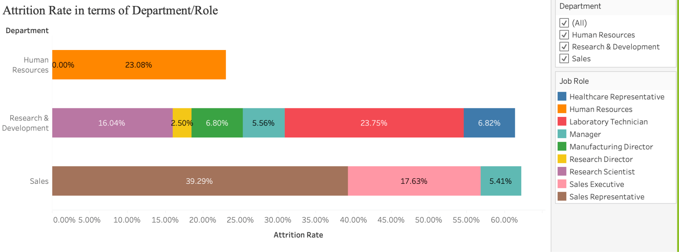

**Attrition Rate in terms of Department/Role**

**Question Addressed:**What is our overall attrition rate, and how does it differ by Department and JobRole?

**Explanation:**This horizontal stacked bar chart breaks down attrition rates by department and further segments them by specific job roles within each department. It addresses the question by showing:

* X-axis = Attrition Rate (percentage of total attrition)
* Y-axis = Department (Human Resources, Research & Development, Sales)
* Color = Job Role (each segment color represents a unique role, shown in the legend)
* Label = Percentage contribution of each role to the total department attrition

From the chart, we can observe that:

* The **Sales** department has the highest overall attrition, with **Sales Representatives** contributing nearly 40%.
* In **Research & Development**, **Laboratory Technicians** and **Research Scientists** have notable attrition.
* **Human Resources** shows attrition only within the Human Resources role itself, with no other roles contributing.

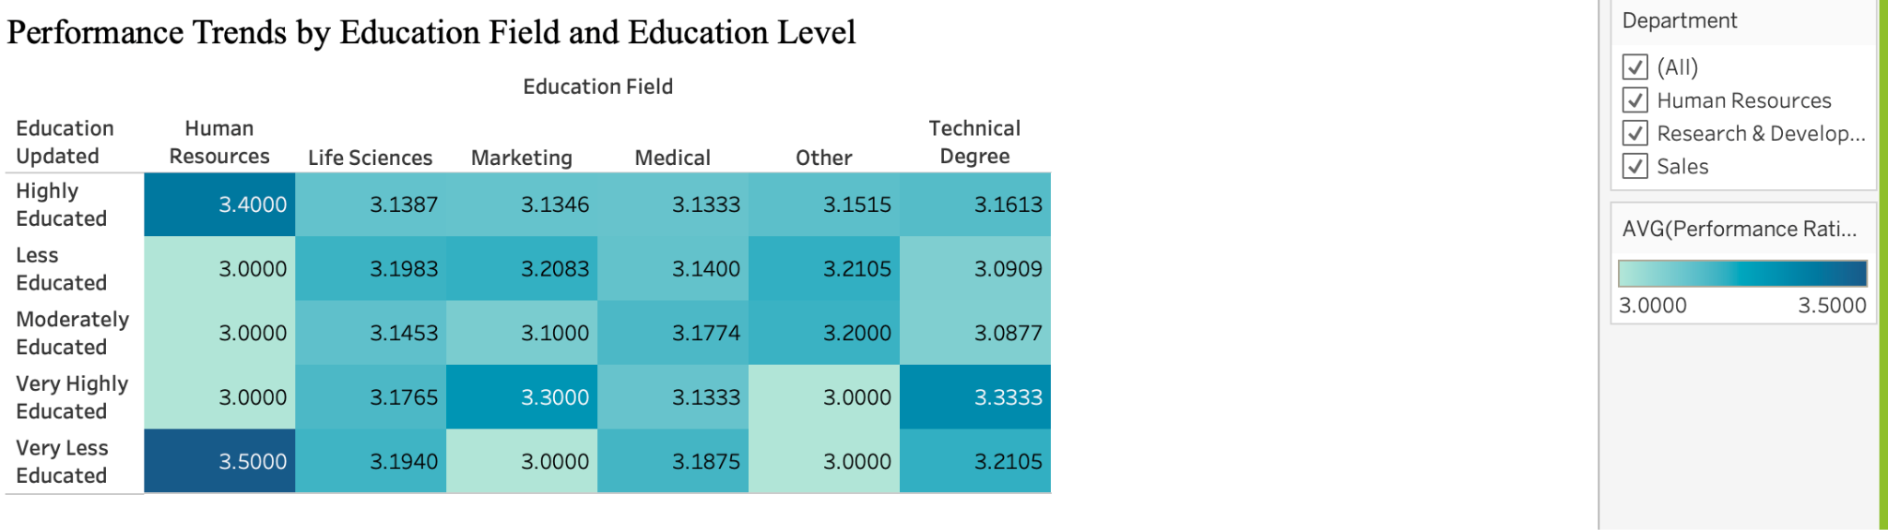

**Performance Trends by Education Field and Education Level**

**Question Addressed:**How do EducationFields and Education levels relate to PerformanceRating?

**Explanation:**This heatmap provides an overview of average performance ratings categorized by combinations of education level and education field. It shows:

* Rows = Education Level (e.g., Very Highly Educated, Moderately Educated)
* Columns = Education Field (e.g., Life Sciences, Marketing, Technical Degree)
* Color = Average Performance Rating (darker shades indicate higher ratings)
* Value = Numeric average performance score inside each cell

From this visualization, we see:

* Some of the highest average ratings come from employees with a "Very Highly Educated" background in "Technical Degree" fields.
* Ratings remain relatively stable, mostly ranging from 3.0 to 3.5, with few extreme outliers.

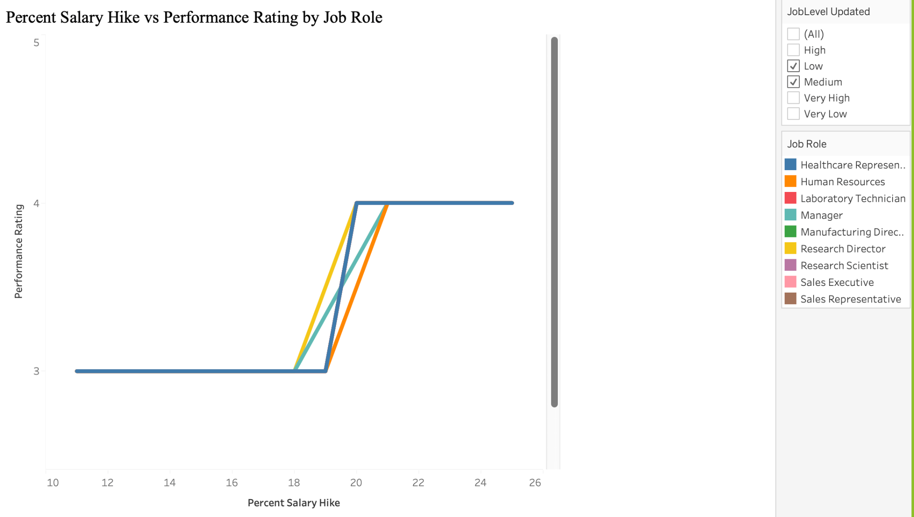**Percent Salary Hike vs Performance Rating by Job Role**

**Question Addressed:**What patterns emerge between PercentSalaryHike and subsequent PerformanceRating?

**Explanation:**This line plot illustrates how performance ratings relate to percent salary hikes for various job roles within selected job levels. It uses:

* X-axis = Percent Salary Hike
* Y-axis = Performance Rating
* Color = Job Role (each line corresponds to a different job role)

The plot reveals that performance ratings are fairly uniform (mostly 3 or 4), with increases in salary hike reflecting small jumps in rating. There is limited variation across roles, indicating salary hikes are fairly standardized relative to performance.

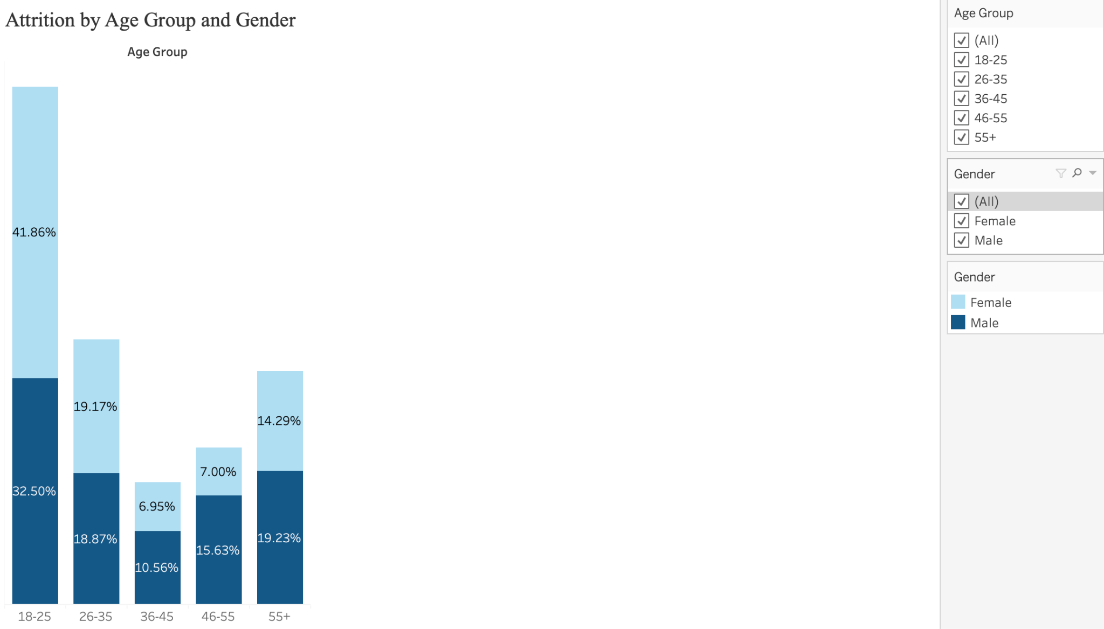

### Attrition Rate by Age Group and Gender

**Question Addressed:** How do attrition rates vary across AgeGroup and Gender?

**Explanation:** This **stacked‐bar chart** shows, for each age bucket, the overall attrition rate (bar height) and its gender split (dark blue = male attrition, light blue = female attrition). You can see which age groups have the highest turnover and whether men or women in that cohort are more likely to leave.

* **X-axis:** AgeGroup buckets (18–25, 26–35, 36–45, 46–55, 55+)
* **Y-axis:** Attrition Rate (percentage)
* **Color:** Gender segments within each bar
* **Size/Length:** Total attrition rate per bucket

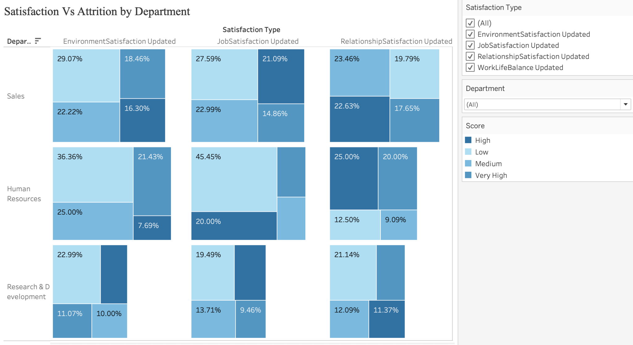

### Satisfaction vs. Attrition by Department

**Question Addressed:** How do the four Satisfaction scores (Environment, Job, Relationship, Work-Life) compare by Department and how do they predict Attrition?

**Explanation:** This **heatmap of squares** arranges Departments on the rows and Satisfaction Type on the columns. Each square’s **color** (light→dark blue) shows the average satisfaction score, and its **size** encodes that department’s attrition rate. You immediately spot which departments and which survey dimensions combine low satisfaction (paler color) with high attrition (larger size).

* **Rows:** Department
* **Columns:** Satisfaction Type (Environment, Job, Relationship, Work-Life)
* **Color:** Avg satisfaction score
* **Size:** Attrition rate

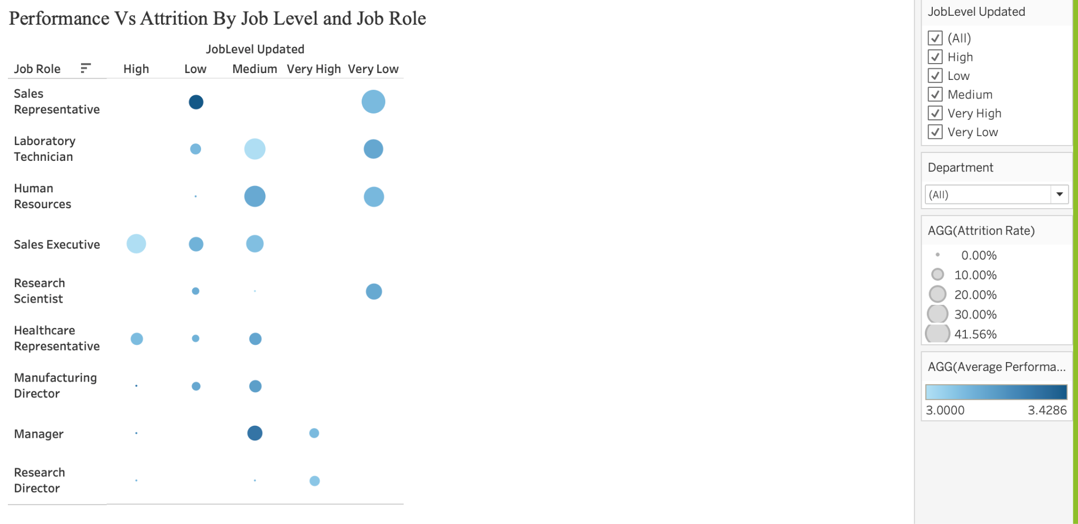

### Performance vs. Attrition by Job Level and Role

**Question Addressed:** Which JobLevels and JobRoles show the strongest PerformanceRating and lowest Attrition?

**Explanation:** A **bubble-matrix** lays out JobLevel on the x-axis and JobRole on the y-axis. Each bubble’s **size** = attrition rate (small = low turnover; large = high turnover) and **color** = avg performance rating on a blue gradient (deep navy = top performers; pale sky-blue = lower performers). This shows at a glance which role/level pairs achieve both strong retention and strong performance.

* **X-axis:** JobLevel_Updated (1 Very Low → 5 Very High)
* **Y-axis:** JobRole
* **Size:** Attrition rate per cell
* **Color:** Avg PerformanceRating

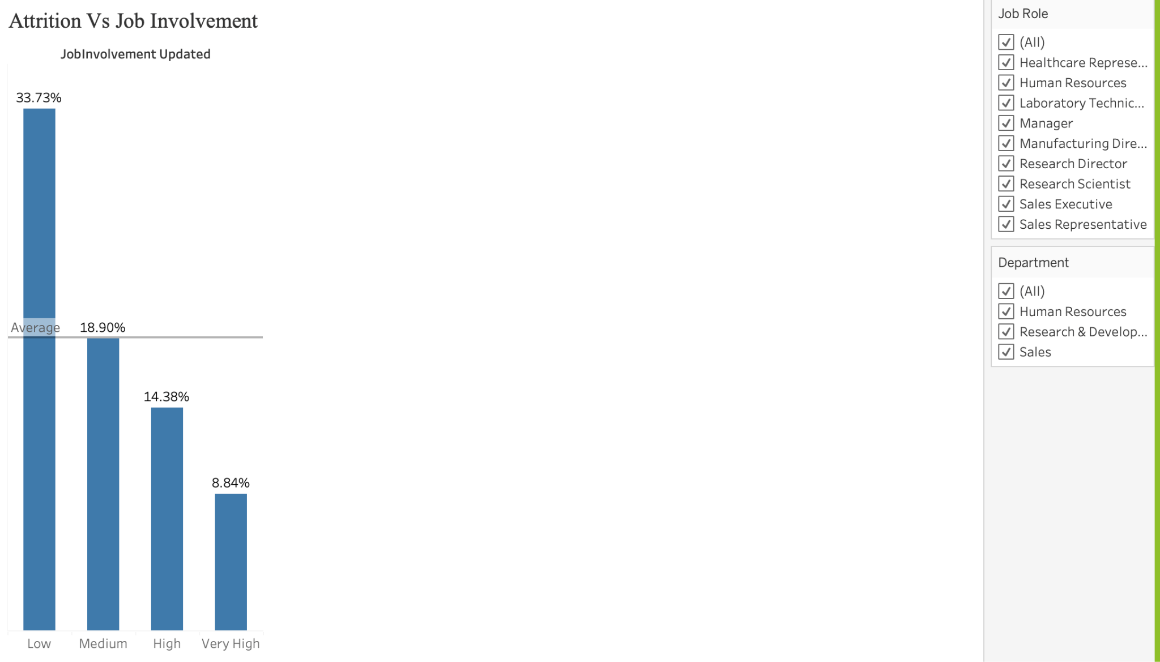

### Attrition vs. Job Involvement

**Question Addressed:** Is lower JobInvolvement associated with higher Attrition?

**Explanation:** This **simple bar chart** places JobInvolvement levels along the x-axis and plots each level’s attrition rate as the bar height. A clear downward slope from “Low” to “Very High” involvement confirms that employees who report lower involvement tend to leave at higher rates.

* **X-axis:** JobInvolvement_Updated (Low, Medium, High, Very High)
* **Y-axis:** Attrition Rate
* **Color:** Uniform (or shaded by rate)
* **Length:** Attrition rate per involvement level

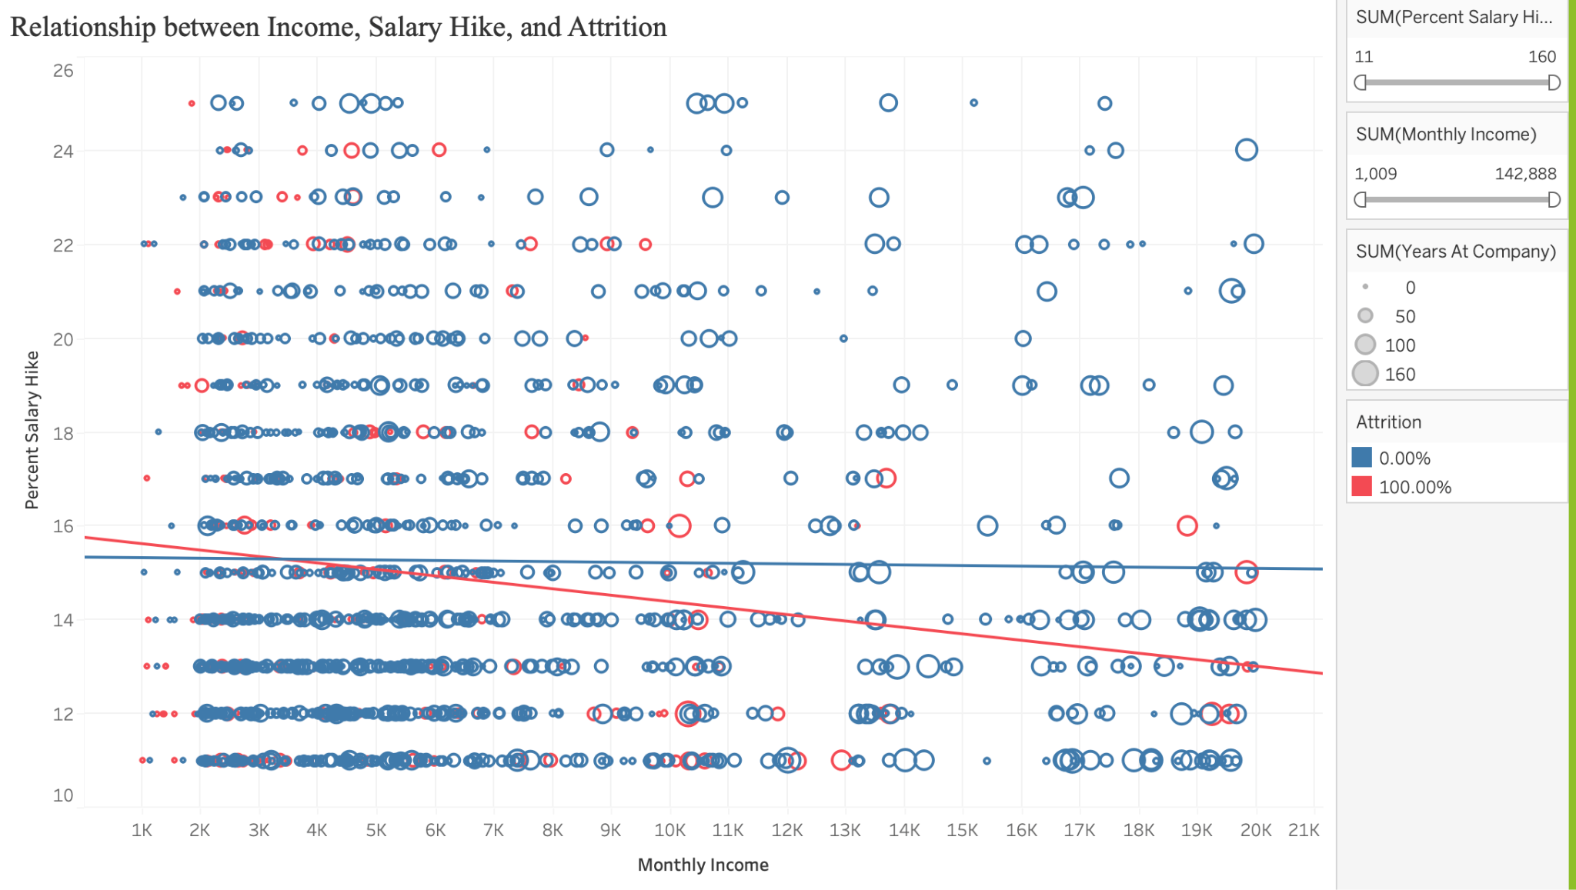

### Relationship between Income, Salary Hike, and Attrition

* **Question Addressed**:  
   Is there a relationship between MonthlyIncome (or PercentSalaryHike) and Attrition?
* **Explanation**:  
   This scatterplot visualizes how employee attrition correlates with salary hikes and income. Each dot represents an employee, with:  
  + X-axis = Monthly Income
  + Y-axis = Percent Salary Hike
  + Color = Attrition status (red = attrition occurred, blue = stayed)
  + Size = Years at Company  
     A trend line is overlaid to observe whether there's any general pattern. The chart reveals that employees with lower income and lower salary hikes are more likely to leave.

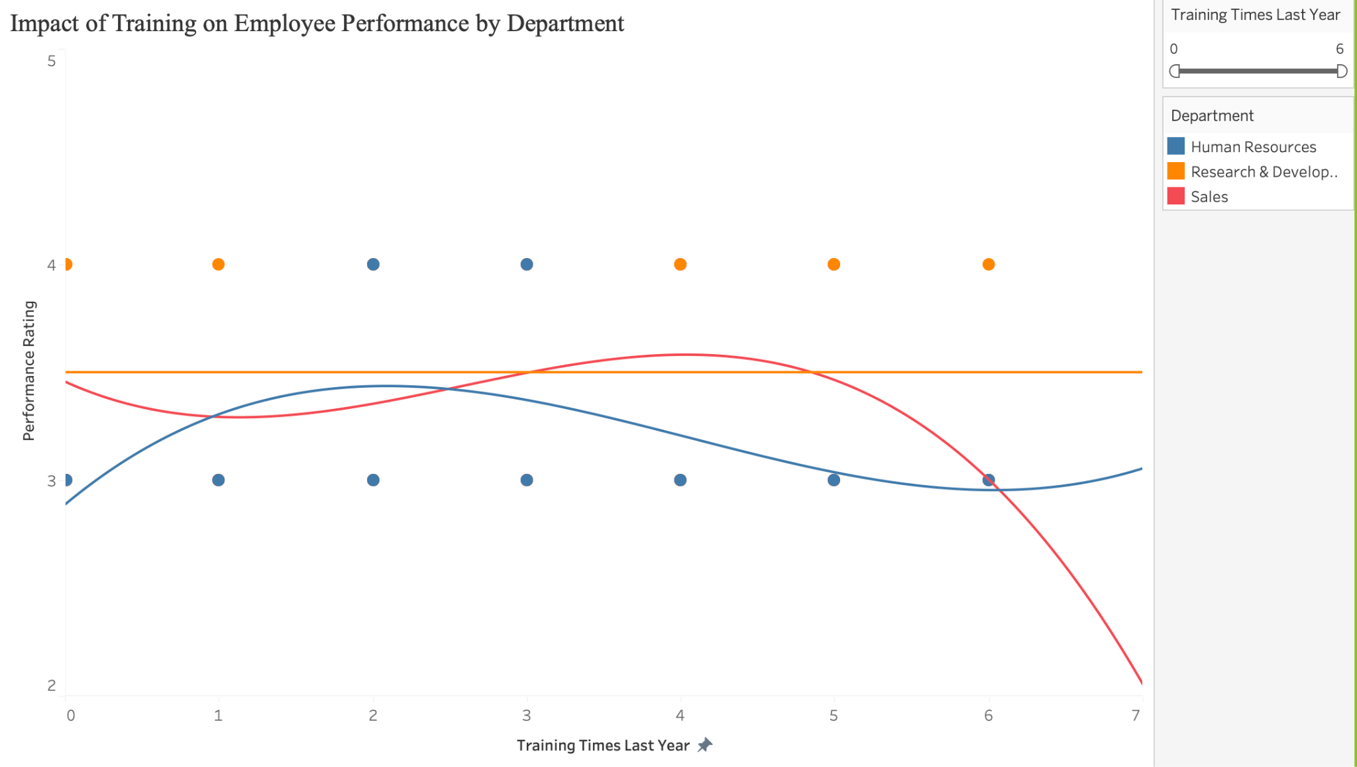

### Impact of Training on Employee Performance by Department

* **Question Addressed**:  
   Does TrainingTimesLastYear drive higher PerformanceRating*?*
* **Explanation**:  
   This scatterplot with polynomial trend lines shows how training influences employee performance across different departments. The data points are color-coded by department. Separate trend lines for each department help compare whether increased training is associated with improved performance. For instance, R&D shows an upward curve, suggesting training boosts performance, while HR trends downward.

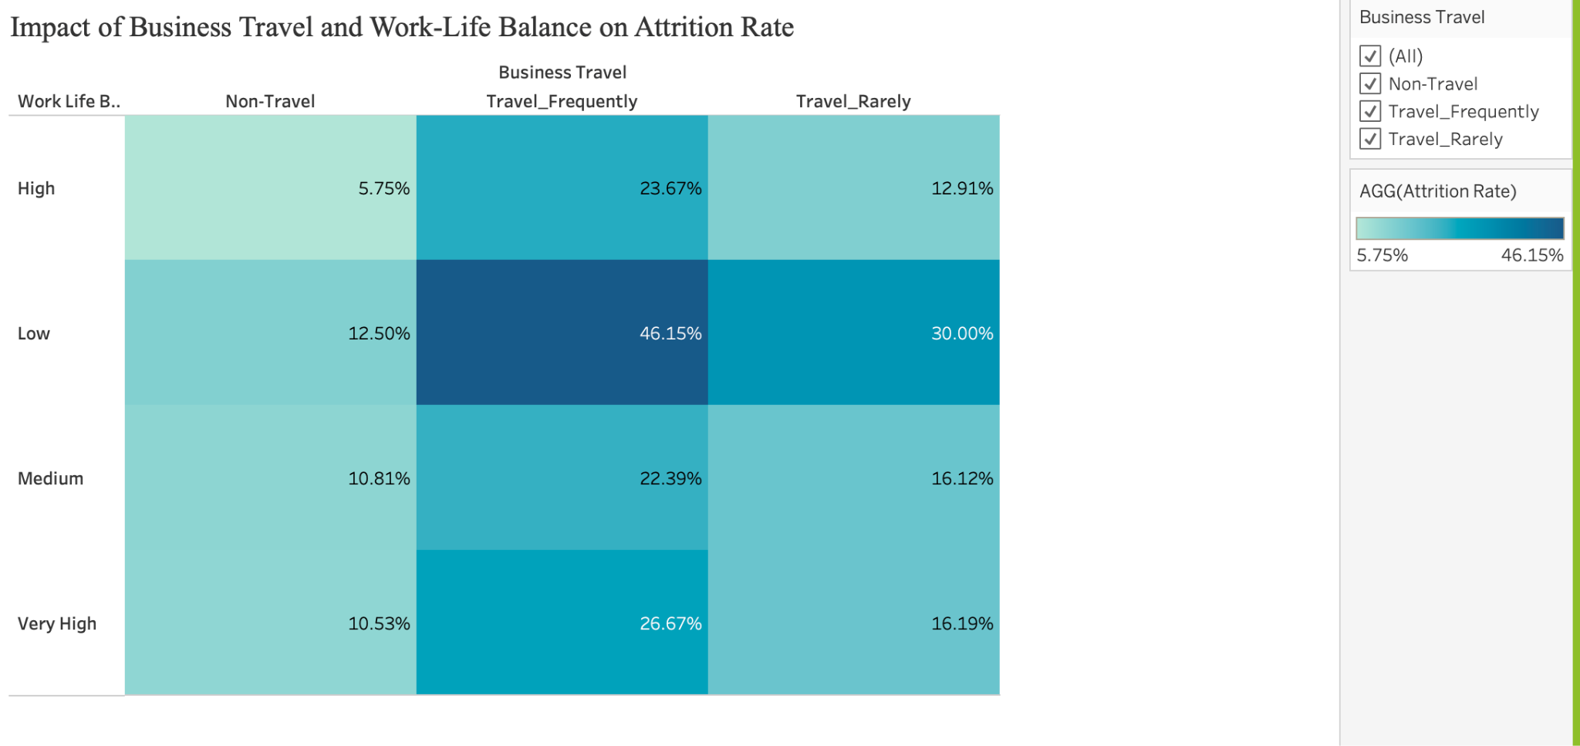

### Impact of Business Travel and Work-Life Balance on Attrition Rate

* **Question Addressed**:  
   How do BusinessTravel categories (Rarely, Frequently, None) affect WorkLifeBalance and Attrition*?*
* **Explanation**:  
   This heatmap presents the average attrition rate for different combinations of business travel frequency (columns) and work-life balance ratings (rows). The intensity of the red color represents higher attrition. The darkest red is seen where travel is frequent and work-life balance is low, highlighting that these employees are most at risk for attrition.

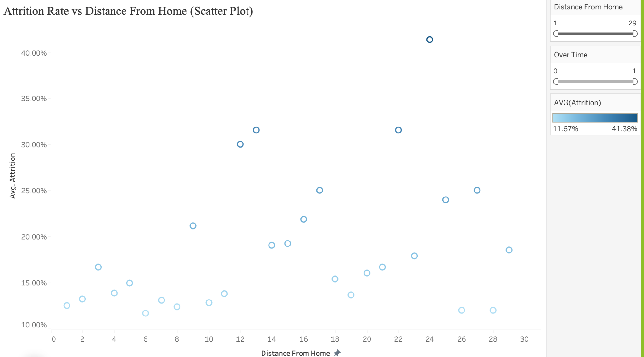

**Plot : Attrition Rate vs Distance From Home**

**Question Addressed**:  
 How does DistanceFromHome correlate with OverTime and Attrition?

**Explanation**:  
 This scatter plot visualizes the average attrition rate at various distances from home.

* **X-axis**: Distance from Home (in miles)
* **Y-axis**: Average Attrition Rate
* **Color**: Blue gradient indicating attrition severity (darker = higher average attrition)

Each point represents a group of employees who live at a specific distance from work. The color intensity helps to quickly spot areas with high attrition. The chart shows notable peaks in attrition at specific distance values (e.g., 13 and 23 miles), suggesting that commute distance may influence employee turnover.

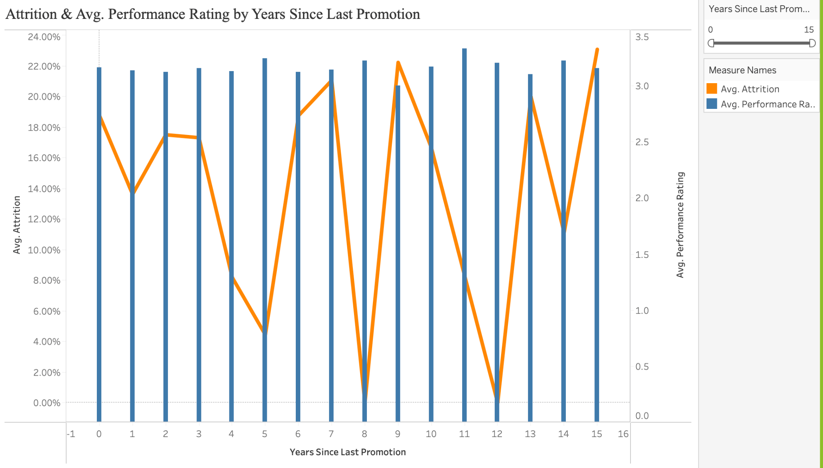

**Plot : Attrition & Avg. Performance Rating by Years Since Last Promotion**

**Question Addressed**:  
 How does YearsSinceLastPromotion impact both Attrition risk and PerformanceRating?

**Explanation**:  
 This dual-axis combo chart displays how employee attrition and average performance rating vary based on the number of years since their last promotion.

* **X-axis**: Years Since Last Promotion
* **Left Y-axis (Line)**: Average Attrition Rate (blue line)
* **Right Y-axis (Bar)**: Average Performance Rating (orange bars)

The chart helps identify if employees who haven’t been promoted in a long time tend to leave more frequently or show a drop in performance. For instance, there are spikes in attrition around years 7, 9, and 15, indicating dissatisfaction possibly due to lack of career progression. Meanwhile, performance ratings remain fairly consistent, suggesting attrition may not always correlate with poor performance.

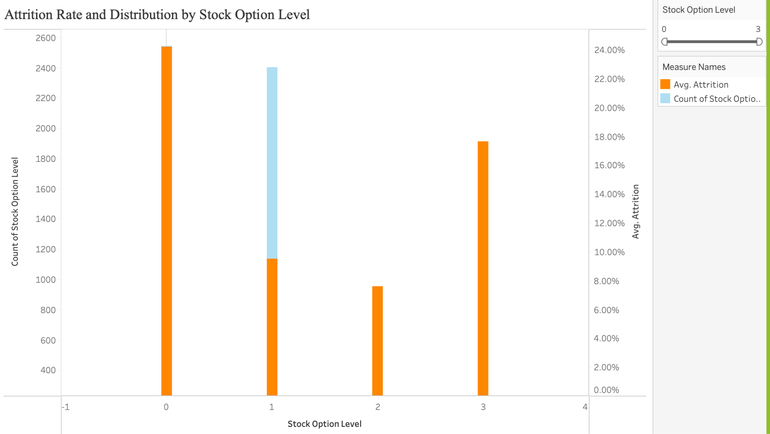

**Plot : Attrition Rate and Distribution by Stock Option Level**

**Question Addressed**:  
 What’s the distribution of StockOptionLevel, and do richer equity packages boost retention?

**Explanation**:  
 This dual-axis bar chart displays two important aspects related to stock option levels:

* **X-axis**: Stock Option Level (ranging from 0 to 3)
* **Left Y-axis (Light Blue Bar)**: Count of Employees at each stock option level
* **Right Y-axis (Dark Blue Bar)**: Average Attrition Rate for employees at each level

The plot reveals that:

* A large number of employees fall under stock option levels 0 and 1.
* Attrition is **highest** for stock option level **0**, suggesting that lack of stock incentives may contribute to employee turnover.
* Attrition rates are significantly **lower** for higher stock option levels (2 and 3), implying that stock options may improve employee retention.

This visualization effectively highlights the correlation between financial incentives and employee loyalty.

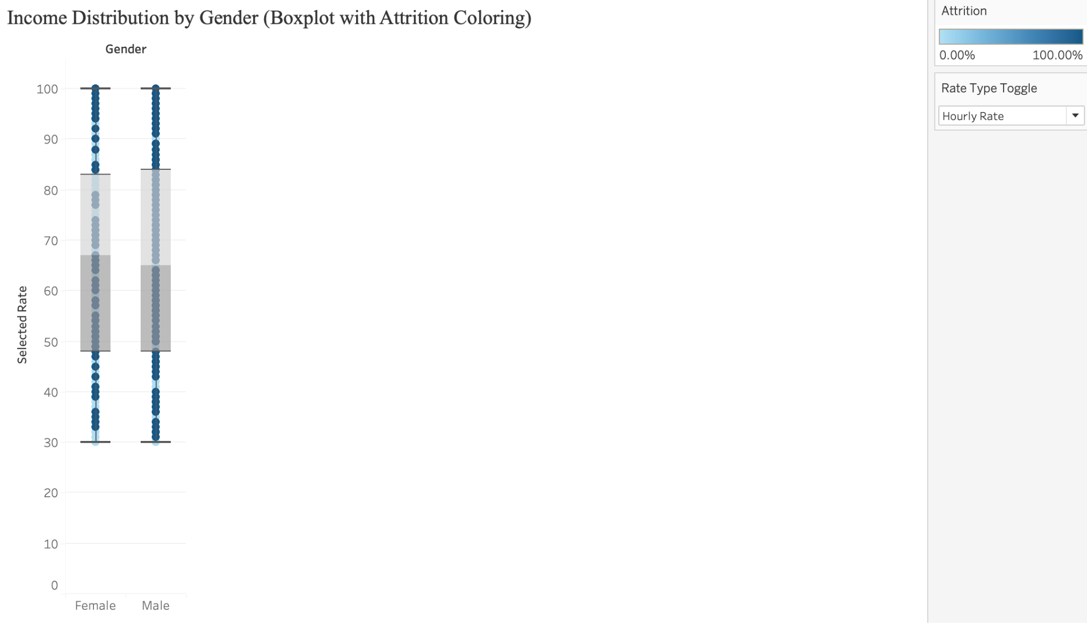

**Plot : Income Distribution by Gender (Boxplot with Attrition Coloring)**

**Question Addressed**:  
Are there gender‐based differences in pay rates (HourlyRate, DailyRate, MonthlyIncome) that correlate with Attrition?

**Explanation**:  
 This boxplot visualizes income distribution (e.g., hourly rate) for male and female employees while using color to represent attrition likelihood.

* **X-axis**: Gender (Female, Male)
* **Y-axis**: Hourly Rate (or another income-related metric depending on selection)
* **Color**: Attrition (0 = light blue = stayed, 1 = dark blue = left)

Each dot represents an individual employee. The box represents the interquartile range (middle 50% of values), with whiskers showing overall spread.

The color gradient reveals whether employees with higher or lower pay are more likely to leave. If darker shades appear more frequently at lower pay levels, it may indicate that lower-paid employees are at greater risk of attrition. The side-by-side comparison also helps determine if there are significant differences in pay structure by gender.

## Section 6: Interactivity

#### Controls Included in the Dashboard:

**Attrition Rate in terms of Department/Role**

* **Department Filter (Checkboxes):**Allows users to select one or more departments to display in the plot. This dynamically updates the chart to reflect only the selected departments, enabling focused analysis.
* **Job Role Legend (Color-Coded):**While not a traditional filter, the legend supports easy identification of job roles within each department. It allows users to visually correlate attrition percentages with roles based on color

**Percent Salary Hike vs Performance Rating by Job Role**

* **Job Level Filter (Checkboxes):** Enables users to include/exclude specific job levels (e.g., Low, Medium) to focus analysis on salary-performance patterns for those levels.
* **Job Role Legend:** Allows quick identification of roles via color-coding, helping differentiate the performance-hike relationship visually.

**Performance Trends by Education Field and Education Level**

**Department Filter (Checkboxes):** Filters the heatmap data to show only the selected departments, allowing users to focus on performance trends specific to departments like Sales or R&D.

**Color Scale Legend:** Provides a visual cue for interpreting average performance rating values, ranging from 3.0 to 3.5.

**Gender Filter**

* **Used for:** Including or excluding male and/or female employee cohorts
* **Applies to:** Attrition by AgeGroup & Gender
* **Range:** Loaded from the **Gender** field: {Male, Female}

**Age Group Filter**

* **Used for:** Limiting the view to specific age buckets
* **Applies to:** Attrition by AgeGroup & Gender
* **Range:** Loaded from the **AgeGroup** field: {18–25, 26–35, 36–45, 46–55, 55+}

**Department Filter**

* **Used for:** Focusing on one or more functional teams
* **Applies to:** Satisfaction vs Attrition by Department, Performance vs Attrition by JobLevel & JobRole), Attrition vs Job Involvement
* **Range:** Loaded from the **Department** field (e.g. Sales, Research & Development, Human Resources, etc.)

**Satisfaction Type Filter**

* **Used for:** Showing or hiding specific survey metrics
* **Applies to:** Satisfaction vs Attrition by Department
* **Range:** Loaded from the **Satisfaction Type** field: {Environment, Job, Relationship, Work-Life}

**Job Level Filter**

* **Used for:** Selecting one or more seniority tiers
* **Applies to:** Performance vs Attrition by JobLevel & JobRole
* **Range:** Loaded from **JobLevel_Updated**: {Very Low, Low, Medium, High, Very High}

**Job Role Filter**

* **Used for:** Drilling into particular job titles
* **Applies to:** Performance vs Attrition by JobLevel & JobRole and Attrition vs Job Involvement
* **Range:** Loaded from the **JobRole** field (all job titles in the dataset)

**Job Involvement Filter**

* **Used for:** Zooming in on specific levels of employee involvement
* **Applies to:** Attrition vs Job Involvement)
* **Range:** Loaded from **JobInvolvement_Updated**: {Low, Medium, High, Very High}

**Monthly Income Slider**

* **Used for**: Filtering employees by their income level.
* **Applies to**: Relationship between Income, Salary Hike, and Attrition.
* **Range**: Automatically determined from Monthly Income data (e.g., 1,009 to 35,722).

**Percent Salary Hike Slider**

* **Used for**: Narrowing down the range of salary hikes to focus on specific employee segments.
* **Applies to**: Relationship between Income, Salary Hike, and Attrition.  
  **Range**: Based on values from Percent Salary Hike (e.g., 11% to 40%).

**Training Times Last Year Slider**

* **Used for**: Filtering how many times employees received training in the year.
* **Applies to**: Impact of Training on Employee Performance by Department.
* **Range**: Typically from 0 to 6 sessions.

**Business Travel Dropdown Filter**

* **Used for**: Selecting which travel categories to display (Non-Travel, Travel Rarely, Travel Frequently).
* **Applies to**: Impact of Business Travel and Work-Life Balance on Attrition Rate.
* **Range**: Categorical; not numerical.

**Plot : Attrition Rate vs Distance From Home**

1. **Over Time Slider**
   * **Used for**: Potential time-based filtering (e.g., if data were collected over time).
   * **Applies to**: Currently appears unused, but may be reserved for temporal data segmentation in future iterations.
   * **Range**: 0 to 1 (default setting, not dynamically active).
2. **Distance From Home Slider**
   * **Used for**: Filtering the data points shown in the scatter plot by selecting a specific range of distances.
   * **Applies to**: Plot 1 (Attrition Rate vs Distance From Home).
   * **Range**: 1 to 29 miles.
3. **AVG(Attrition) Color Legend**
   * **Used for**: Visual interpretation only (not interactive).
   * **Applies to**: Plot 1.
   * **Range**: Color gradient from light blue (lower attrition) to dark blue (higher attrition), based on average attrition rate values ranging from **0.1167** to **0.4138**.

These controls allow users to interactively explore the effect of commuting distance on attrition, enabling more focused analysis of employee segments based on how far they live from work.

**Plot : Attrition & Avg. Performance Rating by Years Since Last Promotion**

1. **Years Since Last Promotion Slider**
   * **Used for**: Filtering the chart to show only a selected range of values for “Years Since Last Promotion.”
   * **Applies to**: Plot 2 (Attrition & Performance Rating).
   * **Range**: 0 to 15 years.
2. **Measure Names Filter**
   * **Used for**: Toggling the visibility of either **Avg. Attrition** or **Avg. Performance Rating** or both.
   * **Applies to**: Plot 2.
   * **Functionality**: Users can isolate one metric at a time for better clarity or compare both simultaneously.

These controls allow users to dynamically explore the relationship between time since last promotion and both attrition and performance, making it easier to draw actionable insights based on filtered views.

**Plot : Attrition Rate and Distribution by Stock Option Level**

1. **Stock Option Level Slider**
   * **Used for**: Filtering which stock option levels (0–3) are shown in the chart.
   * **Applies to**: Plot 3 (Attrition and Stock Option Distribution).
   * **Range**: 0 to 3.
2. **Measure Names Filter**
   * **Used for**: Selecting which metrics to display — either **Avg. Attrition**, **Count of Stock Option Level**, or both.
   * **Applies to**: Plot 3.
   * **Functionality**: Helps in isolating specific insights (e.g., just attrition rate without counts).

These controls allow the user to interactively explore how varying stock option levels impact employee distribution and attrition, enabling targeted policy recommendations around incentive structuring.

**Plot : Income Distribution by Gender (Boxplot with Attrition Coloring)**

1. **Attrition Color Scale**
   * **Used for**: Indicating whether an employee left (1) or stayed (0) using color coding.
   * **Applies to**: Plot 4.
   * **Range**: 0 (light blue) to 1 (dark blue).
2. **Rate Type Toggle Dropdown**
   * **Used for**: Switching between different income types (e.g., Hourly Rate, Monthly Income).
   * **Applies to**: Plot 4.
   * **Functionality**: Allows users to explore gender-based distribution and attrition patterns across multiple types of pay, offering more flexibility in analysis.

This interactivity enables dynamic comparisons across gender, pay types, and attrition status, helping organizations identify possible equity gaps or retention issues tied to compensation.